**FUNCTIONS**

1) **String Manipulation:** Create a function that takes a string as input and returns the string in reverse order.

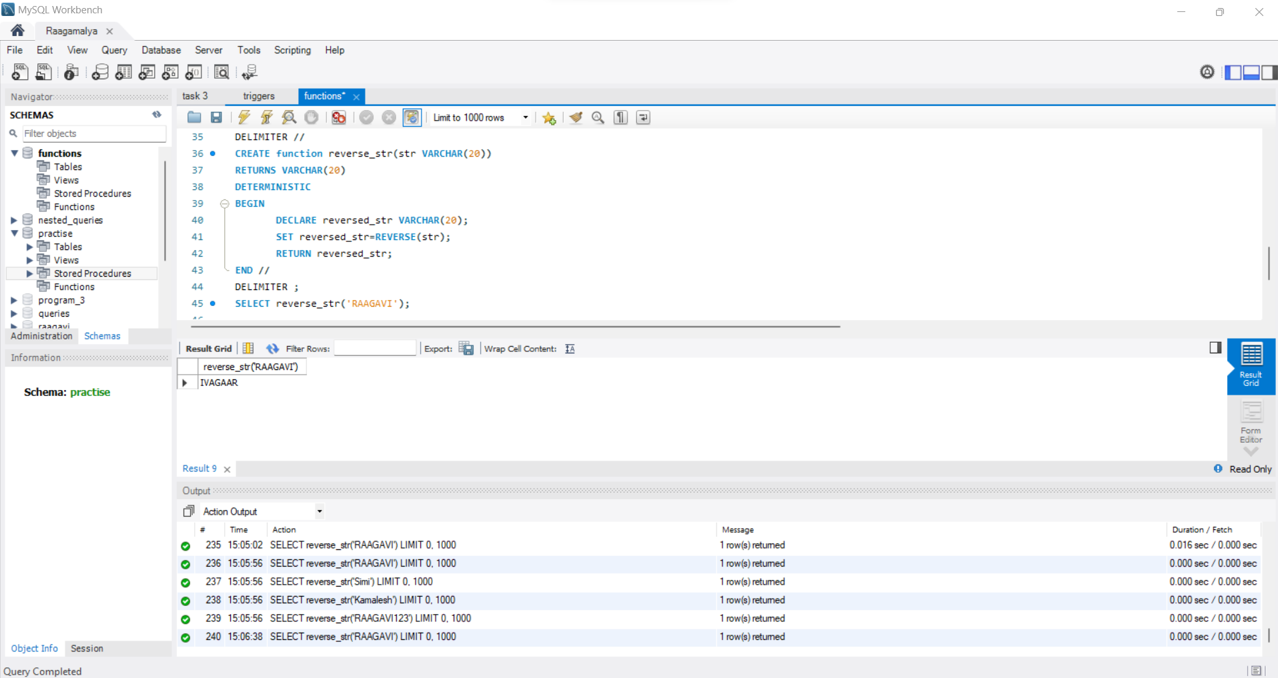

2) **Date Calculations:** Create a function that calculates the age of a person based on their birthdate.

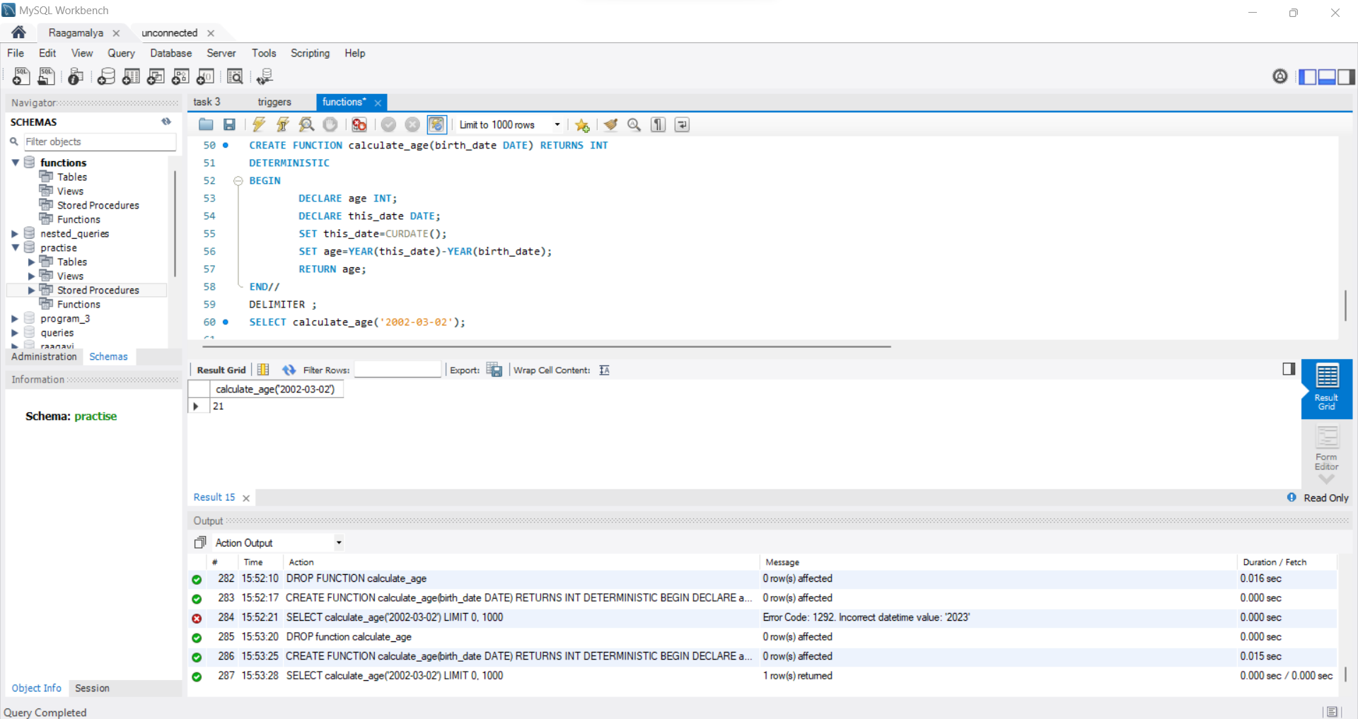

3) **Mathematical Operations:** Create a function that calculates the factorial of a given number.

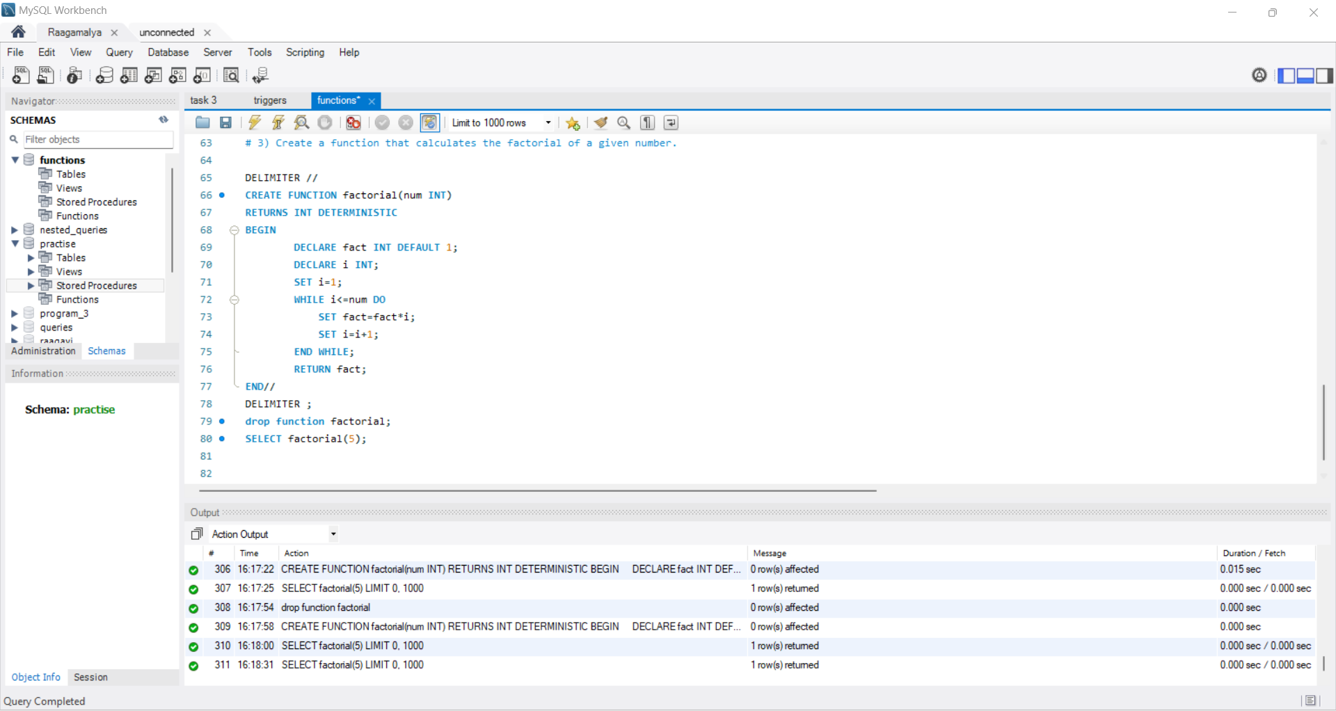

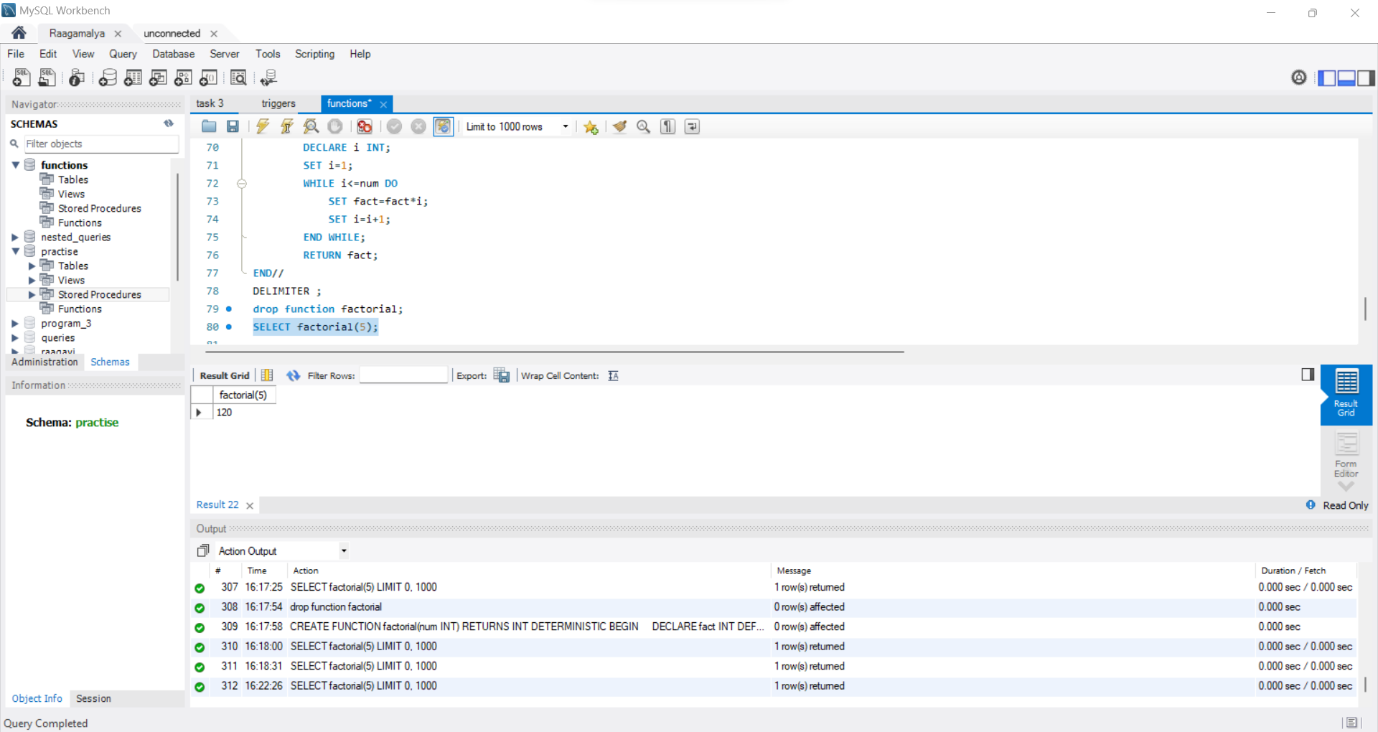

**4) Conditional Logic:** Create a function that takes two numbers as input and returns the larger of the two.

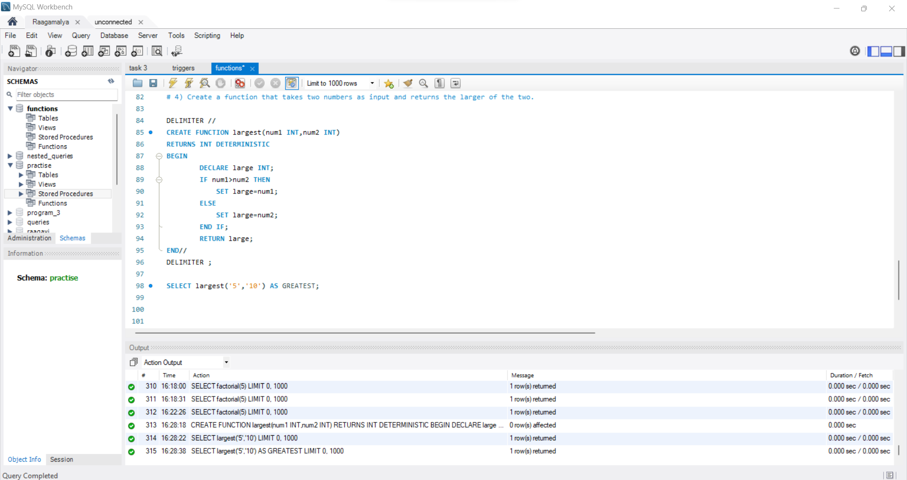

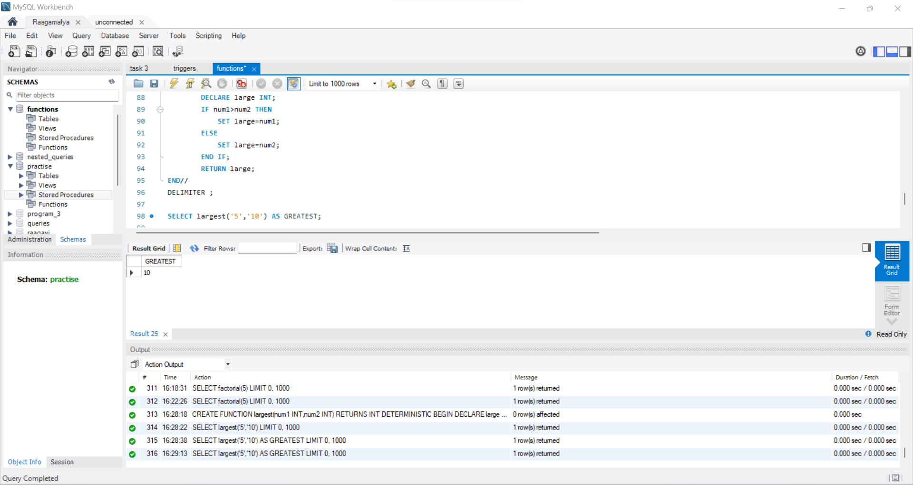

**STORED PROCEDURE**

1) **Insertion with Validation:** Create a stored procedure that inserts a new record into a "Students" table. The procedure should validate that the age is not negative before inserting.

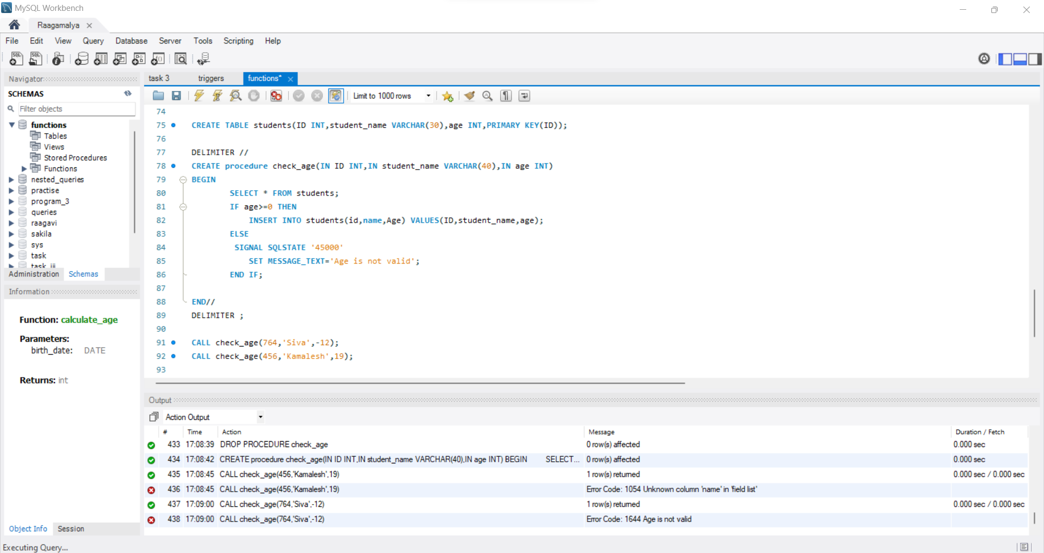

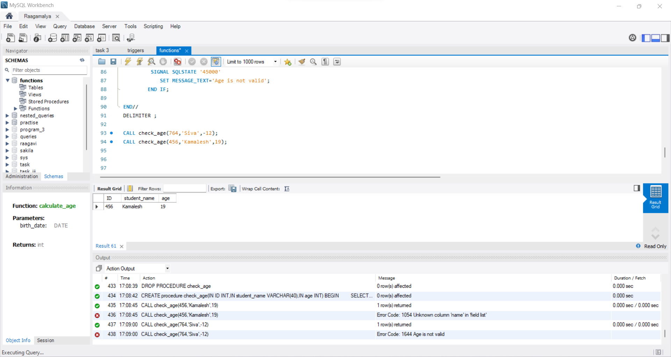

2) **Update with Logging:** Create a stored procedure that updates the email address of a student in the "Students" table. Before updating, the procedure should log the old and new email addresses into an "Audit_Log" table.

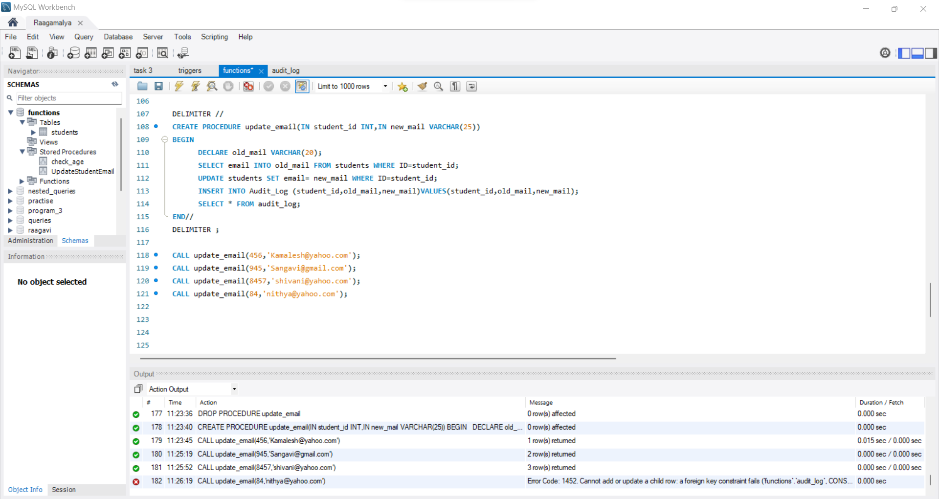

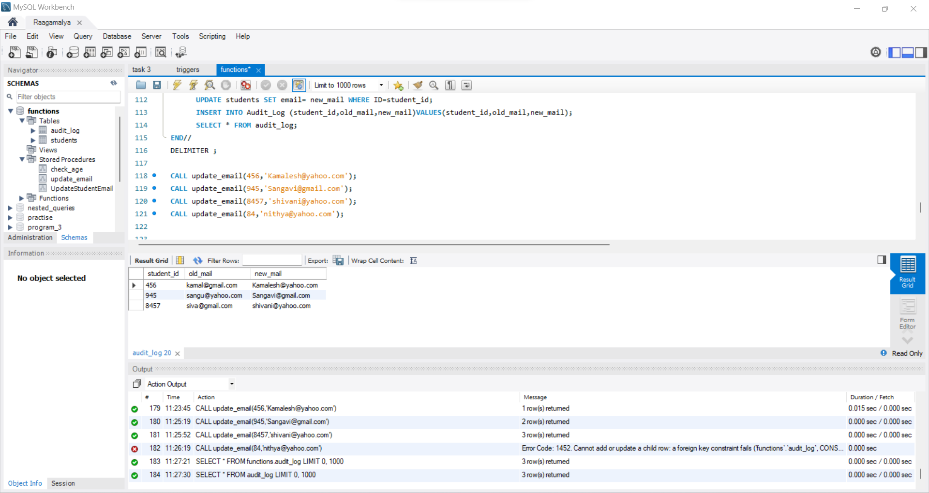

3) **Bulk Insertion:** Create a stored procedure that takes a list of student names and inserts them into the "Students" table in a single transaction.

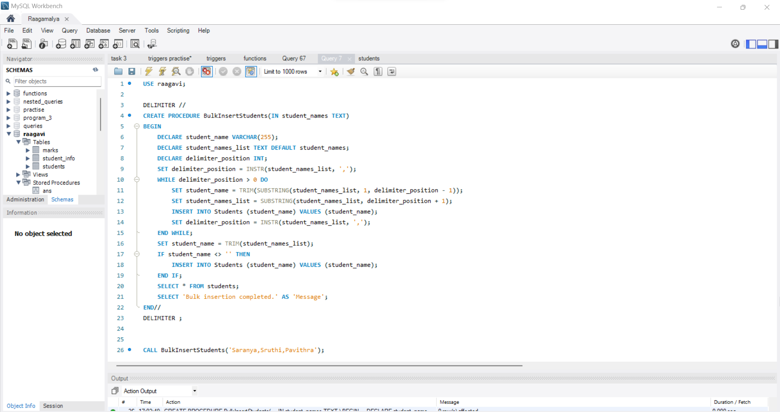

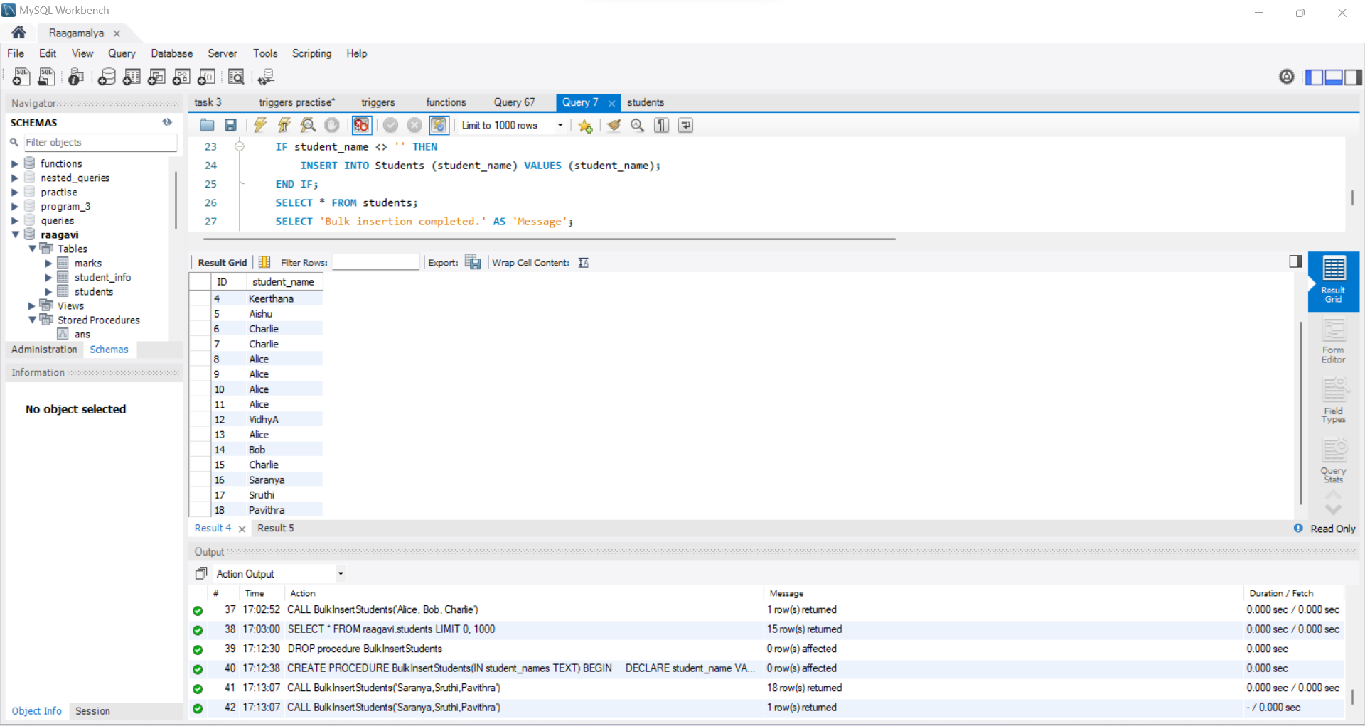

4) **Transaction Rollback:** Create a stored procedure that transfers funds from one bank account to another. Ensure that the transaction is rolled back if the balance in the source account is insufficient.

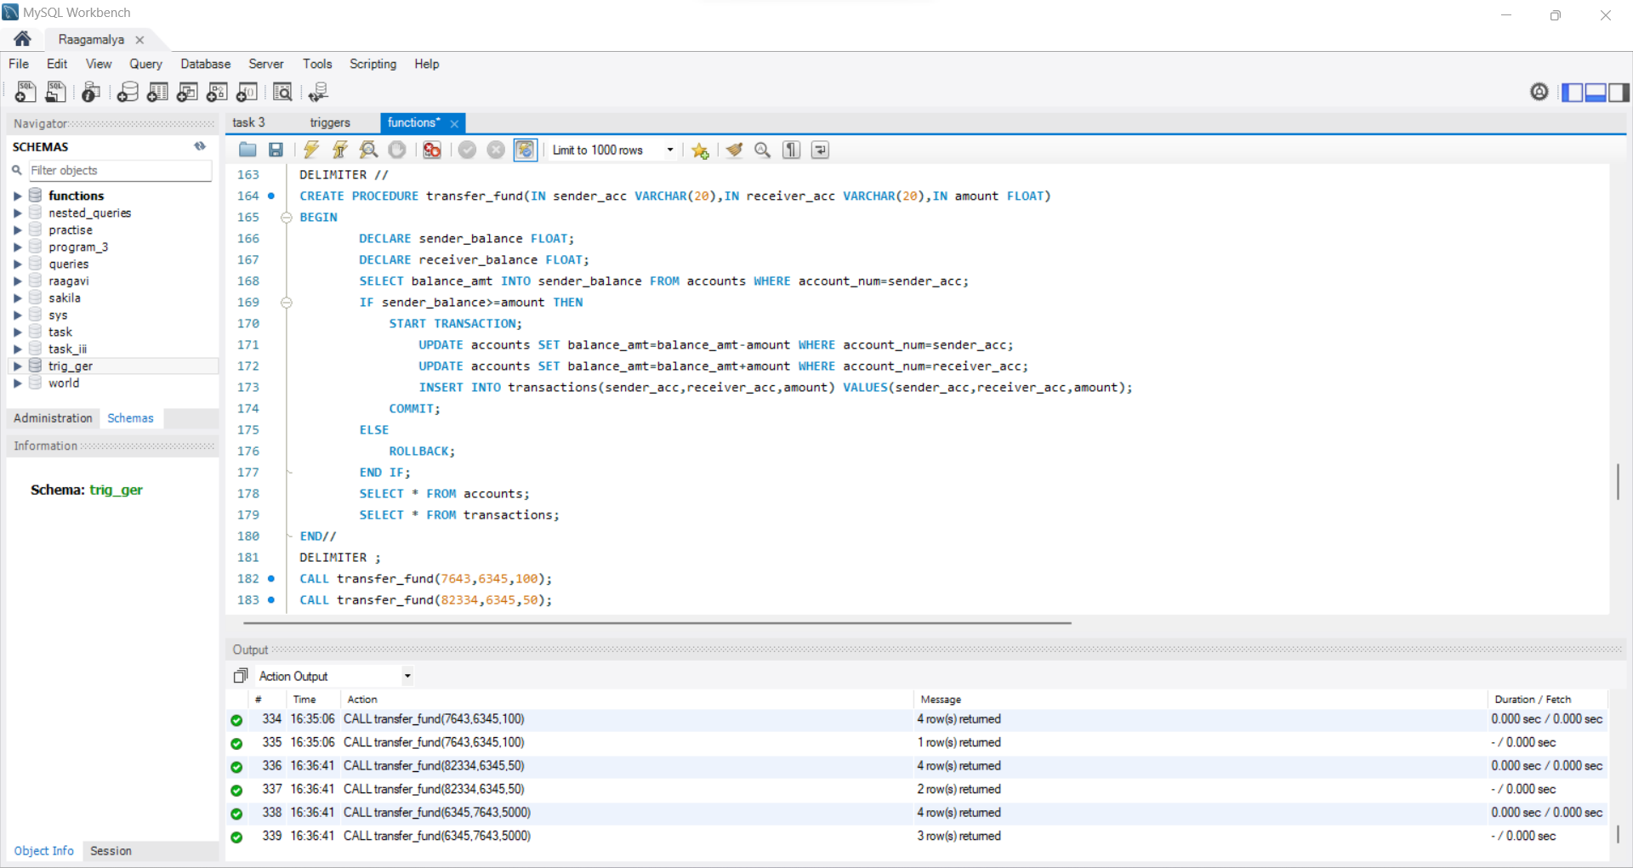

Account table:

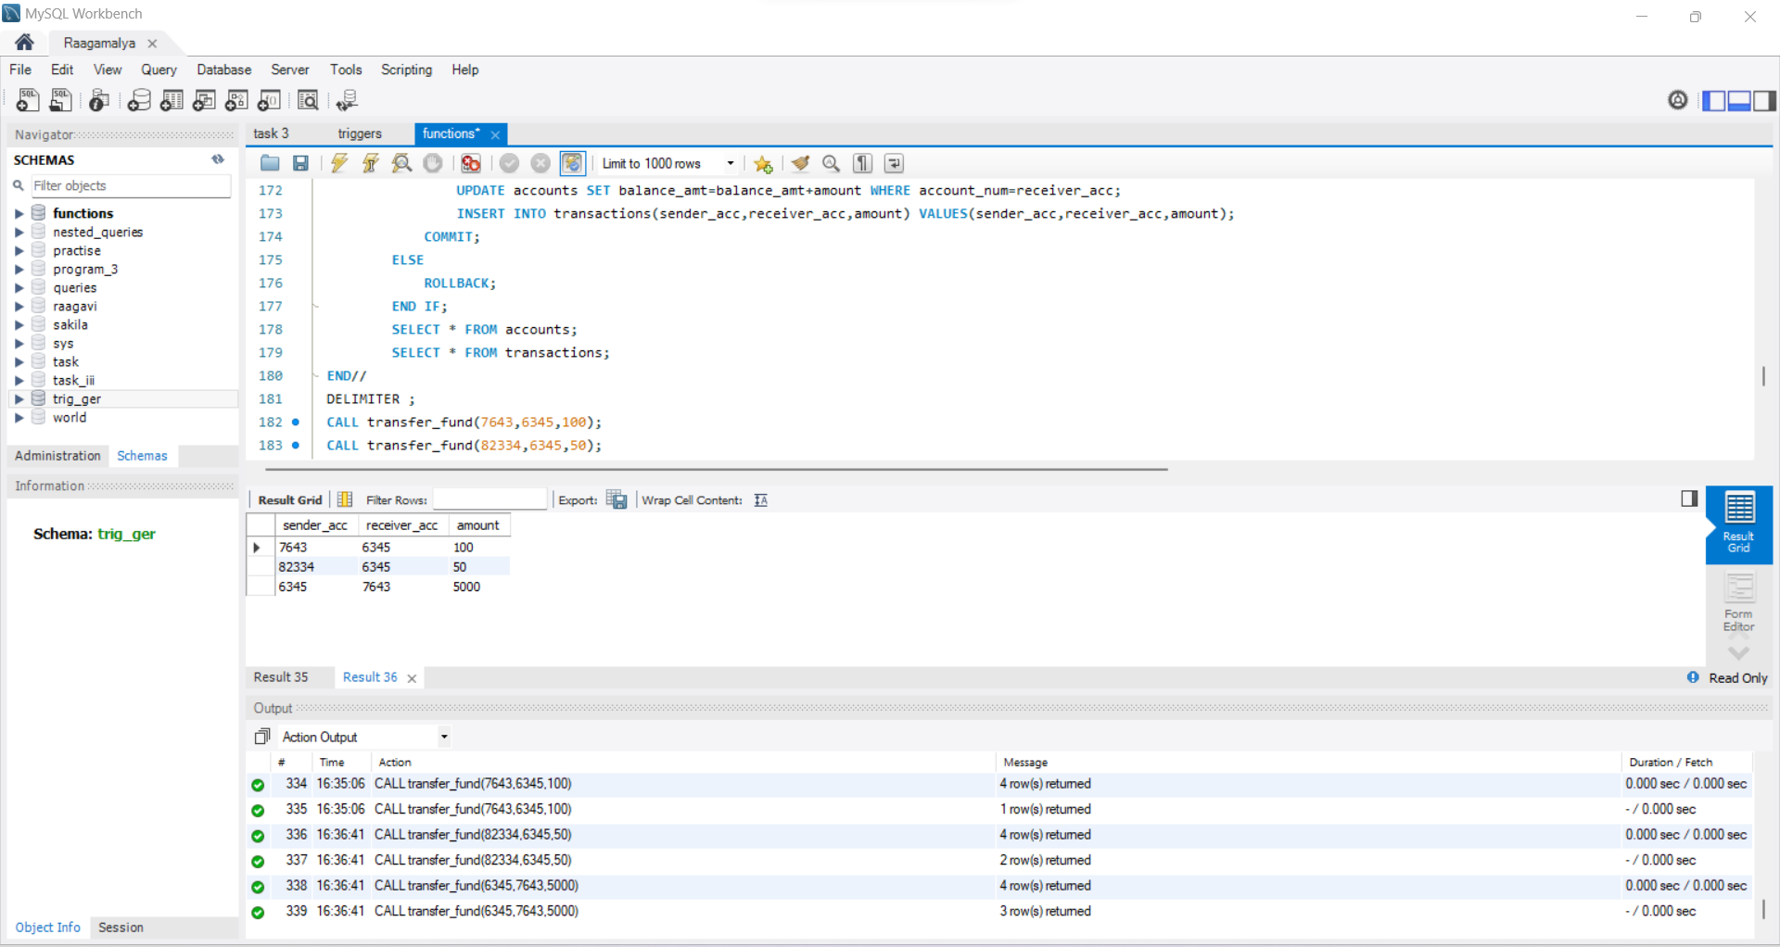

Transaction table:

